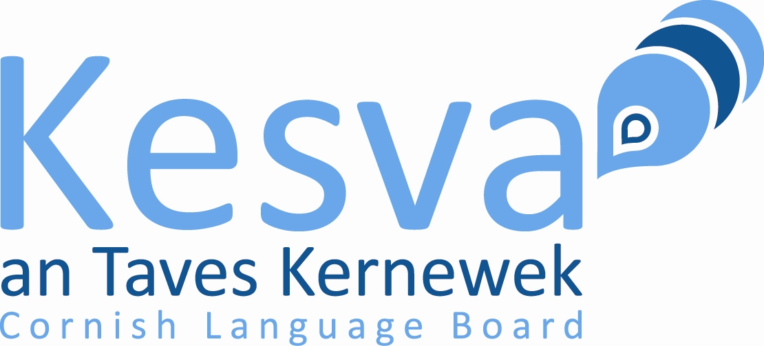
Form-Omrolya Kessedhek Apposyansow Nessa Gradh

Examinations for 2025. You MUST read the document '2025 Examinations – Arrangements' (on the Kesva website – www.kesva.org – under 'Examinations') before completing this form. Completed forms MUST be returned by April 22nd.

Name:
Email address: |  | Telephone:
Postal address:
Teacher's Name: | Spelling: KEMMYN / SWF |  | Special Needs: YES / NO
(If you have special needs please contact the General Secretary to discuss how you might be helped)

If you are taking the Written Examination complete Section A below:
A. Written Examination
Choose your place of examination; if this is ‘home’ please complete the section for an invigilator who will oversee the examination. The examination paper will be sent to the invigilator, preferably by email. The invigilator may print the paper if you so wish.
Place of Examination: Truro or Liskeard or Home
Invigilator's Name:
Specify below EITHER an email address OR postal address for the invigilator. Preferably choose email
Email address:
Postal address:

If you are taking the Oral Examination complete Section B below:
B. Oral Examination – Listening and Comprehension
You must nominate an invigilator who will oversee the examination. It may be your teacher or someone else. The examination paper will be sent to the invigilator, preferably by email. The invigilator may print the paper if you so wish. The sound file will be sent either as an MP3 file by email or as a CD by post. Please try to make arrangements that will facilitate the use of an MP3 file.
Invigilator's Name: | Sound File: MP3 / CD
Specify below EITHER an email address OR postal address for the invigilator. Preferably choose email:
Email address:
Postal address:

Oral Examination – Conversation, Role Play
These parts of the oral examination will be conducted by a Kesva examiner, either face-to-face or using a video-conferencing facility, preferably Zoom. If this is impossible the examination will be conducted by phone and the examiner will discuss with you in advance arrangements for getting the role play instructions to you.
You will be contacted by the Kesva examiner to arrange a date and time for the examination.

I agree to my name being published in the press: YES / NO
I agree to my name being given to Cornish language organisations: YES / NO

Send this form to
apposyans@kesva.org and pay the fee of £10 by PayPal, account cornishexs@gmail.com
Or post the form with a cheque for £10 payable to Kesva an Taves Kernewek Or for BACS payment please contact Maureen Pierce, General Secretary 16 Trelawney Rd, Callington, Kernow PL17 7EE
For any queries contact Maureen Pierce - email apposyans@btinternet.com (preferably) or phone 01579 382511

