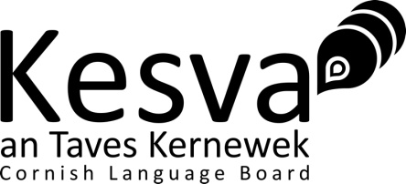
  Mis Metheven 2025 | June 2025
  1ª Gradh (FSS) | 1st Grade (SWF)
  2 our | 2 hours

Paper Skrifys – Yeth
Written Paper - Language

Name (print)……………………………………………………………..

Candidate number ………………………………………………………

Signature ………………………………………….…………………….

Complete the box above.

Answer all questions using the space provided on the question paper.

Write in blue or black ink.

Maximum possible marks for each question are given in brackets.

Take care to write clearly and answer in complete sentences where appropriate.

Extra paper is available on request.

Write your name on any extra sheet(s) of answer paper you use.

Write the question number clearly if you are using an extra sheet.

No papers may be removed from the examination room by the candidate.

Dictionaries may not be used in the written part of the examination.

Examiner’s Use Only
G1 - /24 | G2 - /5 | G3 - /12 | G4 - /9 | G5 - /5 | G6 - /20 | G7 - /25 | Sommen

Question 1 (24 marks)

a) Pyth yw hemma? b) Yw hemma kath?
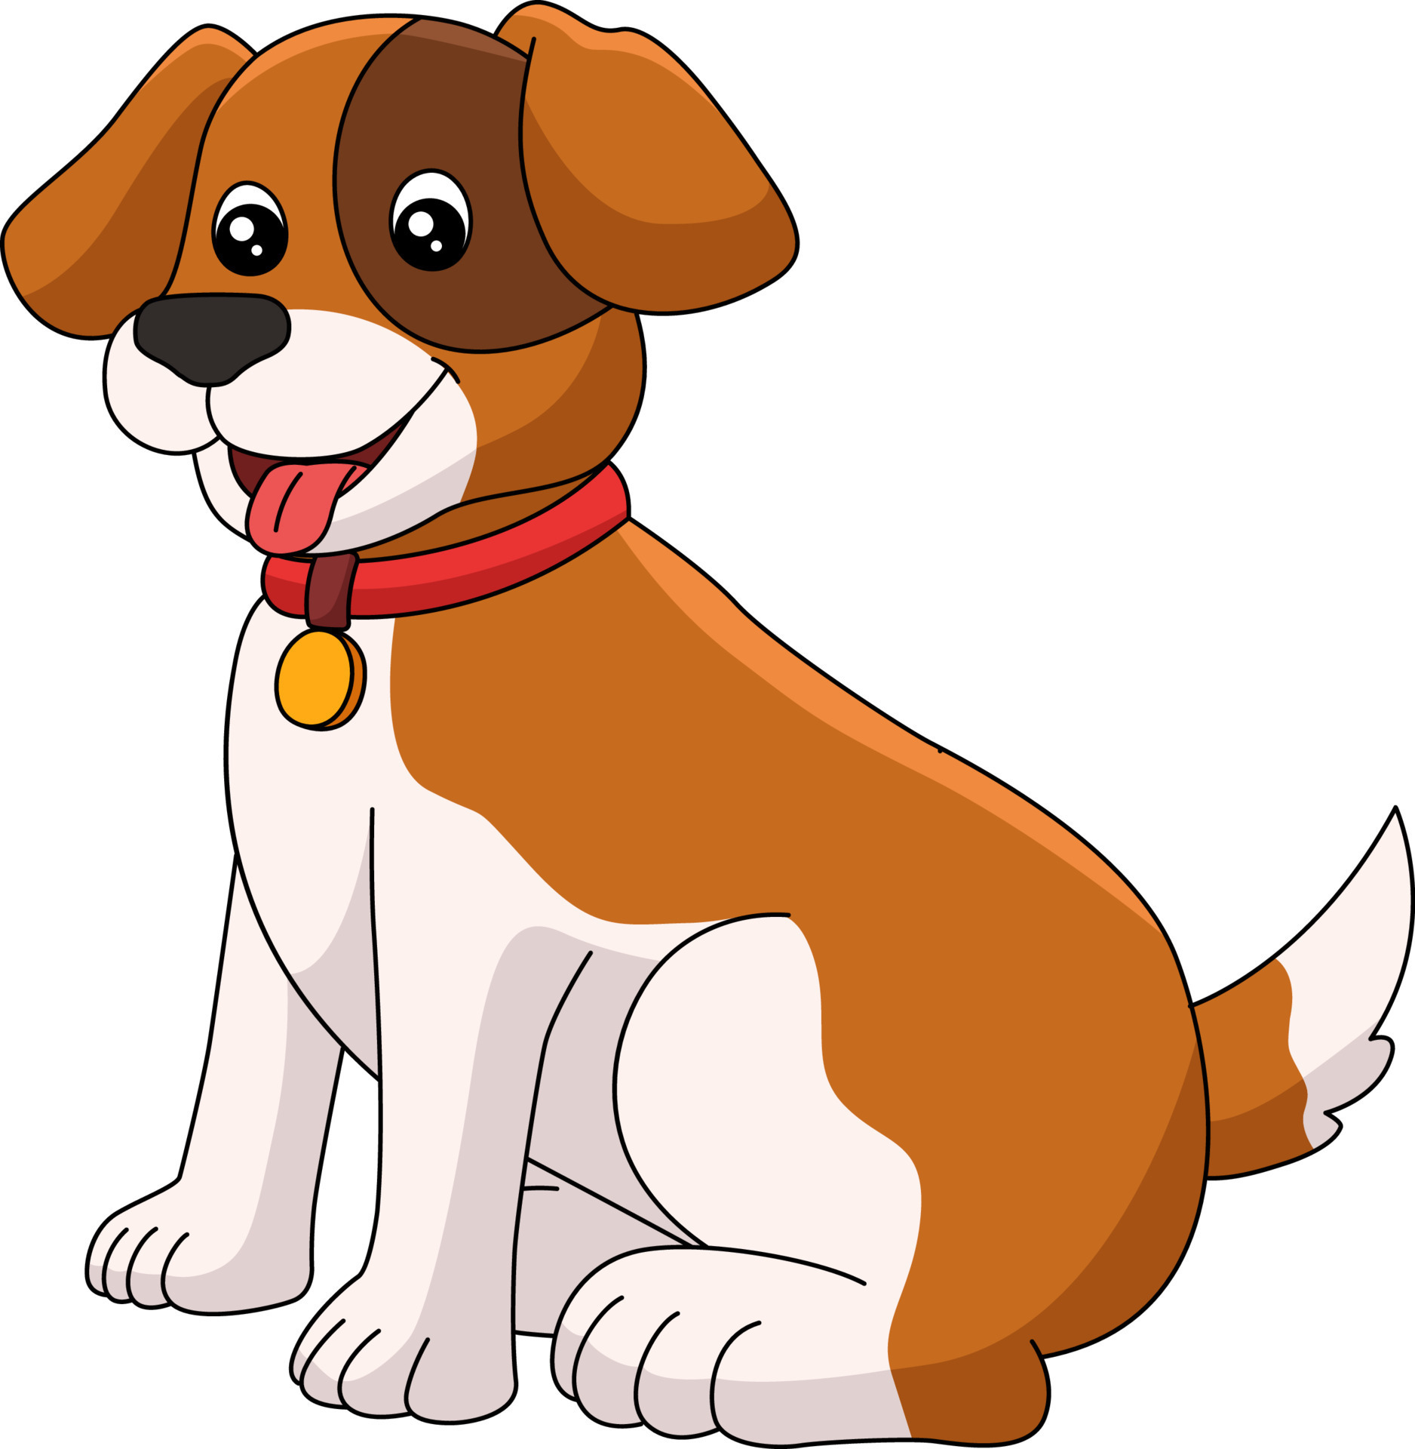
……………………………………… ………………………………………
……………………………………… ………………………………………
c) Ple’ma an maw? d) Fatel yw an gewer?

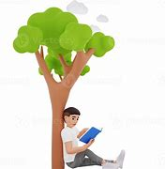

……………………………………… ………………………………………
……………………………………… ………………………………………
e) Py liw yw an karr? f) Esons i ow ponya?


……………………………………… ………………………………………
……………………………………… ………………………………………
g) Pyth usi an den ow kul? h) Py eur yw hi?

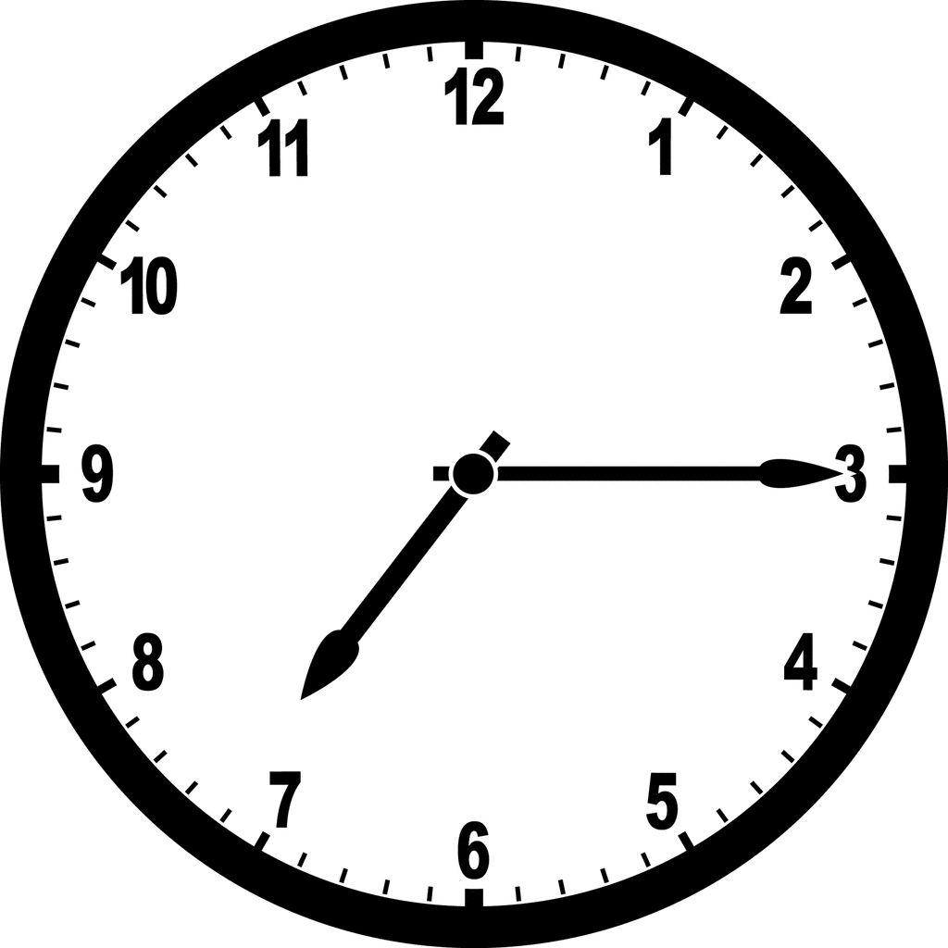

……………………………………… ………………………………………
……………………………………… ………………………………………
Question 2 (5 marks) Find the word which does not fit with the others
a) skrifa redya hemma lewya eva ……………………………………… …
b) karr amari kert kyttrin diwros ………………………………………….
c) rudh melyn glas gwyrdh plos ………………………………………….
d) dyskador myrgh tas gwynn modrep broder ………………………………..……..
e) aval peren owraval kowlvleujen lymmaval ...........................................................

Question 3 (12 marks) Answer the following questions in Cornish.

a) Pyth yw dha hanow?……...………………………………………………………..…..
………………………………………………………………………………………………….
b) Eus ki dhis?………………………………………………………………………….….
……………………………………………………………………………………………..,…..
c) A wruss’ta kerdhes war an treth hedhyw? …………………………………………….
…………………………………………………………………………………………………
d) Yw da genes redya?……………………………………………………………………
………………………………………………………………………………………………….

Question 4 (9 marks) Translate the following into English

a) My a wrug lewya dhe Bennsans de rag mires orth an skathow y’n porth.
………………………………………………………………………………………………..
………………………………………………………………………………………………..
b) “A vyn’ta kemeres hanafas a goffi?” a wovynnas ow mamm. “Ni a yll esedha y’n lowarth y’n howlsplan.”
…………………………………………………………………………………………..……
…………………………………………………………………………………………..……

Question 5 (5 marks) Match the Cornish places with the English meaning

a) Pentire (Penn tir) = ……………………………………………………
b) Penzance (Penn Sans) = ……………………………………………………
c) Tremough (Tre mogh) = ……………………………………………………
d) Trewoon (Tre goon) = ……………………………………………………
e) Porthtowan (Porth Tewyn) = ……………………………………………………

i) moor farm ii) holy head iii) sandy harbour
iv) end of the land v) pig farm
Question 6 (20 marks) Read the following passage. Do not translate it. Answer the questions below, in complete sentences, in Cornish.

Dydh howlyek o yn gwenton. Yth esa an teylu Penrose y’n gegin ow mires yn-mes a’n fenester.
“A yllyn ni mos rag kerdh y’n pow ha dri li genen ha’y dhybri y’n koos?” a wovynnas Lowena ha Tristan.
“Gyllyn!” a worthebis Mamm.
Ytho gans li yn sagh bras, an teylu a gerdhas a-hys an bownder dhe’n pow. I a wrug treusi park gans deves hag eyn ynno hag yth esa lies edhen ow neyja a-ugh. Tas a wrug ygeri an yet ha’n teylu a welas koos byghan gans le perfydh rag kroust. I a wrug degea an yet arta. Ny vynsons i gasa an yet ygor rag an deves. Oll a-dro yth esa bleujennow an gog pur deg. Yth esa moos groust ena ha lowen ens i.
I a esedhas orth an voos ha Mamm a ygoras an sagh ha’n kistyow gans an boos ynna. Yth esa baramanynnow keus ha pastiow byghan, avalow kerensa ha kresigow ynwedh. Wosa henna yth esa avalow rudh ha tesen safran. Rag diwes yth esa sugen owraval rag an fleghes ha te rag Mamm ha Tas.
“Ass yw bryntin an kroust ma” yn-medh an fleghes war-barth. I a dhybris oll an boos. A-wosa i a wrug omlowenhe y’n howlsplan ha gwari gwariow, mes diwettha yth esa meur a gommol y’n ebron hag i a wrug kuntel oll an atal ha’y worra y’n sagh ha mos tre.

a) Py seson o ha fatel o an gewer an jydh na?……………………………....... (2 marks) ...….………………………………………………………………………………….………
b) Pandr’a vynnas an fleghes dhe wul? ………………..….………….……… (3 marks) .………………………………………………………………………………………………
c) Pandr’a wrussons i gweles y’n park? …..……………………...……………(3 marks)
…………………………………………………………………………………………………………..
d) Ple hwrussons i dybri an kroust? ………………………………….…….…..(2 marks)
…………………………………………………………………………………………………
e) Pyth esa y’n sagh? ………………..……………………………………….(6 marks)
………………………………………………………………………………………………...
f) Pandr’a wrussons i wosa an kroust? …….…………………………………(4 marks).
…………………………………………………………………………………………….…..)

Question 7 (25 marks) Write 50 – 100 words in Cornish on one of the following topics
a) Ow mamm (My mother) b) Gwenton yn Kernow (Spring in Cornwall) c) Ow chi (My house)

…………………………………………………………………………………………………………..
……………………………………………………………………………......................................……
…………………………………………………………………………………………………………..
…………………………………………………………………………………………………………..
…………………………………………………………………………………………………………..
…………………………………………………………………………………………………………...
Mis Metheven 2025 | June 2025
1ª Gradh (FSS) | 1st Grade (SWF)

Apposyans War Anow – Gwari Rol – Dasskrif an Ombrofyer
Oral Examination – Role-Play – Candidate’s Copy

The Role-Play is worth 30 marks.

Do not write on this card.

This card may not be removed from the examination room.

You have 10 minutes to prepare the role-play. You may use a dictionary in the preparation of the role-play. You are not allowed help from any source other than the dictionary. You may make notes on the paper provided. You may not use the dictionary in the examination room but you may make use of your notes.

The Role-Play is worth 30 marks.

Do not write on this card.

This card may not be removed from the examination room.

Role-play

You go to collect an order from a shop The salesperson greets you.
The examiner will play the part of the salesperson and will speak first.

- You greet the salesperson and ask if they have your package…
The salesperson asks your name and address
- You give them your name and the address
The salesperson then asks when you ordered it
- You reply it was ordered last Wednesday
The salesperson asks if you have a receipt
- You tell them it is on your phone in an email
The salesperson thanks you and says they will look out the back
- You reply that it is a small package
The salesperson replies that there are lots of small packages
- You agree but say you are in a hurry as you need to catch the bus
The salesperson replies they think they have found it; please can you confirm your address
- You give your address
They reply that it is your order and give it to you
- You thank them
They say sorry it was difficult to find
- You reply that is ok but you must go now
The stranger says that they hope you will be pleased with your order
- You say thank you again and end the conversation appropriately.

EXAMINER’S COPY
  Mis Metheven 2025 | June 2025
  1ª Gradh (FSS) | 1st Grade (SWF)

Apposyans War Anow – Gwari Rol – Dasskrif an Apposyer
Oral Examination – Role-Play – Examiner’s Copy

The following appears on the candidate’s copy:

The Role-Play is worth 30 marks.

Do not write on this card.

This card may not be removed from the examination room.

You have 10 minutes to prepare the role-play. You may use a dictionary in the preparation of the role-play. You are not allowed help from any source other than the dictionary. You may make notes on the paper provided. You may not use the dictionary in the examination room but you may make use of your notes.

The role-play is worth 30 marks.

Do not write on this card.

This card may not be removed from the examination room.

EXAMINER’S COPY
Role-play

You go to collect an order from a shop The salesperson greets you.
The examiner will play the part of the salesperson and will speak first.

- You greet the salesperson and ask if they have your package…
The salesperson asks your name and address
- You give them your name and the address
The salesperson then asks when you ordered it
- You reply it was ordered last Wednesday
The salesperson asks if you have a receipt
- You tell them it is on your phone in an email
The salesperson thanks you and says they will look out the back
- You reply that it is a small package
The salesperson replies that there are lots of small packages
- You agree but say you are in a hurry as you need to catch the bus
The salesperson replies they have found it; please can you confirm your name and address
- You give your address
They reply that it is your order and give it to you
- You thank them
They say sorry it was difficult to find
- You reply that is ok but you must go now
The salesperson says that they hope you will be pleased with your order
- You say thank you again and end the conversation appropriately.

Apposyer: Dydh da, fatel allav vy dha weres?
Ombrofyer: ………
Apposyer: Pyth yw dha hanow ha trigva?
Ombrofyer: ………
Apposyer: Py dydh a wruss’ta erghi an dra?
Ombrofyer: ………
Apposyer: Eus dhis an akwityans?
Ombrofyer: ………
Apposyer: Meur ras. My a wra hwilas a-dhelergh dhe‘n sodhva
Ombrofyer: ……….
Apposyer: Yma meur a fardellow byghan
Ombrofyer: ……….
Apposyer: Ottomma dha fardel. A yll’ta afydhya dha hanow ha trigva arta
Ombrofyer: ………
Apposyer: An fardel ewn yw hemma
Ombrofyer: ………
Apposyer: Drog yw genev bos mar gales dh‘y gavos
Ombrofyer: ……..
Apposyer: My a wayt dha vos pes da gans dha fardel. Duw genes
Ombrofyer: ……..

Mis Metheven 2025 | June 2025
1ª Gradh (FSS) | 1st Grade (SWF)

Apposyans War Anow – Goslowes – Dasskrif an Ombrofyer
Oral Examination – Listening – Candidate’s Copy

Name (print)…………………………………………………………………

Candidate number …………………………………………………………..

Signature ……………………………………………………………………

The Listening Examination is worth 20 marks

Complete the box above.

Do not turn this question paper over until instructed to do so.

Answer all questions in the spaces provided in this booklet.

Write in blue or black ink.

Maximum possible marks for each question are given in brackets.

Take care to write clearly but complete sentences are not required.

Extra paper is available on request.

Write your name on any extra sheet(s) of paper you use.

Write the question number clearly if you are using an extra sheet.

No papers may be removed from the examination room by the candidate.

Dictionaries may not be used in the listening part of the examination.

Listen carefully to the instructions on the tape.
The passage will be read three times with a short pause before each of the readings. You may answer the questions at any time during the readings.

Answer in English.

1) What day is it? (2 marks)
…………………………………………………………………………………………
2) What is the name of the radio station? (1 mark)
…………………………………………………………………………………………
3) What happened in Penzance? (3 marks)
…………………………………………………………………………………………
…………………………………………………………………………………………
4) What are people asked to do? (2 marks)
………………………………………………………………………………………….
5) Where will the road be closed? (2 marks)
…………………………………………………………………………………………
6) When will the road be closed? (3 marks)
…………………………………………………………………………………………
7) Why will the road be closed? (2 marks)
………………………………………………………………………………………….
8) What sort of shop has opened in St Austell? (1 mark)
…………………………………………………………………………………………
9) What can you buy in the new shop? (2 marks)
……………………………………………………………………………………….…
10) What will the weather be like tomorrow? (2 marks)
…………………………………………………………………………………………..

EXAMINER’S COPY
  Mis Metheven 2025 | June 2025
  1ª Gradh (FSS) | 1st Grade (SWF)

Apposyans War Anow – Goslowes – Dasskrif an Apposyer
Oral Examination – Listening – Examiner’s Copy

The following appears on the front of the candidate’s copy:

The Listening Examination is worth 20 marks.

Complete the box above.

Do not turn this question paper over until instructed to do so.

Answer all questions in the spaces provided in this booklet.

Write in blue or black ink.

Maximum possible marks for each question are given in brackets.

Take care to write clearly but complete sentences are not required.

Extra paper is available on request.

Write your name on any extra sheet(s) of paper you use.

Write the question number clearly if you are using an extra sheet.

No papers may be removed from the examination room by the candidate.

Dictionaries may not be used in the listening part of the examination.

EXAMINER’S COPY

Transcript of the sound file:
Kesva an Taves Kernewek 2025.
This is the listening comprehension test for the 1st Grade oral examination.
Turn over your answer paper. You now have one minute to read the questions.
<Pause 1 minute>
The passage will be read three times with a short pause before each reading.
You may answer the questions at any time during the readings.

Radio news items.
Myttin da. Eth eur yw hag yth esowgh hwi ow koslowes orth Radio Lowen. Ottomma an nowodhow rag hedhyw dy’Lun an 7^{ves} a vis Gortheren redys gans Maria Polglase.
An kreslu a wra hwilas dew dhen neb a entras chi yn Pennsans nosweyth dy’Gwener eus passyes. I a wrug ladra gemweyth kostek ha myns bras a arghans. Mar kwrussowgh hwi gweles an dhew dhen mar pleg gwrewgh kestava an sodhva kreslu yn Pennsans.
An fordh dhyworth Truru dhe Aberfala yw deges an seythen ma yn Pennrynn ynter eth eur gorthugher ha hwegh eur myttin. Hemm yw rag ober tredannek a res. Yma gohelfordh.
Yn Sen Austel de gwerthji nowydh a ygoras. Lyverji yw hag yma lies lyver Kernewek dhe wertha ena. Yma ynwedh kornel rag koffi ha tesen. Pubonan a leveris bos da gweles gwerthji nowydh yn arbennik lyverji. Yth esa meur a brenoryon ena de. Chons da dhe’n perghen
An gewer hedhyw rag Kernow a vydh tomm ha howlyek gans gwyns krev. A-vorow y fydh komolek gans nebes kowasow.

End of first reading.
End of second reading.
End of third reading
You now have two minutes to finalise your answers.
Now stop writing.
This is the end of the listening comprehension test 2025.

The following questions appear on the candidate’s paper:

Answer in English.

1. What day is it? (2 marks)
2. What is the name of the radio station? (1 mark)
3. What happened in Penzance on Friday night? (3 marks)
4. What are people asked to do? (2 marks)
5. When will the road be closed? (2 marks)
6. Where will the road be closed? (3 marks)
7. Why will the road be closed? (2 marks)
8. What sort of shop has opened in St Austell? (1 mark)
9. What can you buy in the new shop? (2 marks)
10. What will the weather be like tomorrow? (2 marks)

EXAMINER’S COPY
Mis Metheven 2025 | June 2025
1ª Gradh (FSS) | 1st Grade (SWF)

Apposyans War Anow – Kewsel – Dasskrif an Apposyer
Oral Examination – Speaking – Examiner’s Copy

The Speaking – unprepared – Examination is worth 30 marks

(there is no candidate copy for this part of the examination.)

(Govynnow a’n par ma…gwelewgh paperyow kyns rag ensamplow erel)

1 Piw os ta? / Pyth yw dha hanow?

2 Ple’th os ta trigys? Ple’ma ….?

3 Fatel yw an gewer hedhyw? Yw an gewer sygh/glyb ... yn Hav?

4 Py eur yw hi? Py eur y hwre’ta mos y’n gweli?

5 Py liw yw an voos/daras/sagh ..? Yw an liw da genes?

6 Py par chi/karr .. eus dhis? Yw ev/hi koth/nowydh/bras/byghan ..?

7 Eus fleghes/enevales dhis? Py lies flogh/eneval eus dhis? / A vyn’ta kavos eneval?

8 Yw da genes kana/donsya/kerdhes/ponya/neuvya? A wre’ta …… yn fenowgh?

9 A wruss’ta mos dhe Gembra / Loundres / Vreten Vyghan...? Pyth eus ena? / A vyn’ta mos ena?

- Py mis yw an mis ma? Py mis yw dha benn-bloodh/penn-bloodh dha
vamm/das/wour/wreg… ?

The Speaking – Prepared – Examination is worth 20 marks

The candidate will be prepared to discuss Ow Thas or Kerdh yn Gwav. These topics will have been set at least three weeks before the examination.
The candidate is to be allowed to start talking and the examiner will then interrupt and ask the candidate some simple questions about the topic which should include at least one request to repeat something and at least one request to elaborate on something.
EXAMINER’S COPY

Mis Metheven 2025 | June 2025
1ª Gradh (FSS) | 1st Grade (SWF)

Apposyans War Anow – Gwari Rol – Merkyow
Oral Examination – Role-Play – Marks

Mark Scheme
Role-Play (30 marks) Ignore incorrect or missing mutations.

Dydh da. Usi genes/genowgh ow fardel /mar pleg?  Dydh da/usi dhis ow fardel/mar pleg | 3  1
Ow Hanow yw hag ow thrigva yw  Hanow/trigva | 3  1
Erghys o dy’Mergher eus passys/my a wrug y erghi dy’Mergher eus passys  erghys /dy’Mergher/erghi | 3  1
Yn ow klapkodh yw an ebost./Yma an ebost yn ow klapkodh  klapkodh/ebost | 3  1
Fardel byghan yw  Fardel/byghan | 3  1
Mes res yw dhymm fistena rag kachya kyttrin  res yw dhymm/fistena/ kyttrin | 3  1
Trigva ewn | 3
Meur ras dhis/dhywgh  Meur ras | 3  1
Da lowr, mes res yw dhymm mos lemmyn  Da lowr/res yw dhymm/mos lemmyn | 3  1
Meur ras dhis/dhywgh arta ha duw genes/genowgh  Meur ras/dhis/duw genes | 3  1
Maximum marks * | 30
*please send RAW marks to the examination board

EXAMINER’S COPY

Mis Metheven 2025 | June 2025
1ª Gradh (FSS) | 1st Grade (SWF)

Apposyans War Anow – Kewsel – Merkyow
Oral Examination – Speaking – Marks

Mark Scheme

Speaking 1 (30 marks)

There are 10 questions. Invigilators may change the questions, but the new question should be of an equivalent level of difficulty.
Question 1 is the confidence-giving question; all candidates should get 3 marks.
The other questions each have a supplementary question; the first part gains 2 marks for a correct understandable answer, regardless of whether it is a complete sentence (this is conversation); one word answers may gain 1 mark. The remaining 1 mark is for an understandable answer to the supplementary question.
Ignore incorrect or missing mutations.

Speaking 2 (20 marks)

Introductory remarks (the first 3 or 4 sentences)
Relevant and correct 5 - 6 marks
Relevant but some errors 3 – 4 marks
Mostly relevant, many errors 1 – 2 marks

Response to discussion

Fluent, obvious understanding, few errors 11 – 14 marks
Quick to respond, understanding good, some errors 7 – 10
Responds when prompted 4 – 6
Usually one word answers only, understanding poor < 4
(ignore incorrect or missing mutations)
EXAMINER’S COPY

Mis Metheven 2025 | June 2025
1ª Gradh (FSS) | 1st Grade (SWF)

Apposyans War Anow – Goslowes – Merkyow
Oral Examination – Listening – Marks

Mark Scheme
Listening (20 marks)

1 | Monday 7th July | 2
2 | Happy Radio/Radio Lowen | 1
3 | Two men entered a house in Penzance and  stole jewellery and money | 2  1
4 | Contact Penzance police station if you saw the men | 2
5 | From Truro to Falmouth/  Penryn | 1  1
6 | This week at night  between 8pm and 6am | 1  2
7 | Necessary electrical work | 2
8 | bookshop | 1
9 | Cornish Books  coffee | 1  1
10 | Cloudy with showers | 2
 | Maximum marks | 20
EXAMINER’S COPY

Mis Metheven 2025 | June 2025
1ª Gradh (FSS) | 1st Grade (SWF)
2 our | 2 hours

Apposyans Skrifys – Yeth – Merkyow
Written Examination – Language – Marks

Mark Scheme

Ignore all incorrect mutations
1a | Homm/Hemm yw kador / Kador yw homma/hemma  Kador yw  Kador (ENSAMPEL) | 3  2  1
1b | Nag yw, nyns yw kath. Ki yw  Nag yw, ki yw./ Nyns yw kath  Nag yw. | 3  2  1
1c | Yma an maw yn-dann/ryb an wedhen  Yn-dann/ryb an wedhen | 3  2
1d | Howlyek/tomm/splann/kosel yw hi  Howlyek/tomm/splann/kosel | 3  1
1e | Melyn yw an karr/ an karr yw melyn  Melyn yw | 3  2
1f | Nag esons, nyns esons i ow ponya. Ymons i ow neuvya  Nag esons. Ymons i ow neuvya. | 3  2
1g | Yma an den ow redya (lyver)  Redya /ow redya | 3  2
1h | Kwarter wosa seyth yw hi/Pymthek mynysen wosa seyth yw hi  Kwarter wosa seyth | 3  1
 | Maximum marks | 24
2a | hemma | 1
2b | amari | 1
2c | plos | 1
2d | dyskador | 1
2e | kowlvleujen | 1
 | Maximum marks | 5
3a | ... yw ow hanow/ Ow hanow yw …  … ov vy  Name only | 3  2  1
3b | Eus, yma ki dhymm. either answer for  Nag eus, nyns eus ki dhymm full marks  Yma ki dhymm/Nyns eus ki dhymm  Eus/Nag eus | 3  3  2  1
3c | Gwrug, my a wrug kerdhes war an treth hedhyw either answer for  Na wrug, ny wrug vy kerdhes war an treth hedhyw full marks  My a wrug/Ny wrug vy kerdhes war an treth  Gwrug/Na wrug | 3  3  2  1
3d | Yw, da yw genev redya/Nag yw, nyns yw da genev redya  Da yw genev/Nyns yw da genev | 3  2
 | Maximum marks | 12
4a | I drove (did drive)  To Penzance  To look at the boats  In the harbour  at least 3 words correctly recognised | 1  1  1  1  1
4b | Do you want to have a cup of coffee?  My mother asked  We can sit  In the garden in the sunshine  at least 3 words correctly recognised | 2  1  1  1  1
 | Maximum marks | 9
5a | iv (end of the land) | 1
5b | ii (holy head) | 1
5c | v (pig farm) | 1
5d | i (moor farm) | 1
5e | iii (sandy harbour) | 1
 | Maximum marks | 5
6a | Gwenton o  Howlyek o | 1  1
6b | I a vynnas mos rag kerdh yn pow  Ha dri li gansa ha dybri kroust y’n koos | 1  2
6c | I a wrug gweles deves hag eyn  Hag ydhyn ow neyja a-ugh | 2  1
6d | Y’n sagh yth esa  Baramanyn keus  Ha pastiow byghan  Avalow kerensa  kresigow  sugen owraval ha te | 1  1  1  1  1  1
6e | I a wrug dybri kroust y’n koos  War voos/orth moos groust | 1  1
6f | I a wrug omlowenhe  Gwari gwariow  Kuntel oll an atal  Ha mos tre | 1  1  1  1
 | Maximum marks | 20
7 | Excellent  Very good  Good  Satisfactory  Fair  Poor  Marks will be awarded for suitable, appropriate content, correct length ± 20%, a range of expressions, correct word order and use of verbs. | 22 – 25  19 – 21  16 – 18  13 – 15  10 - 12  < 10
 | Maximum marks | 25

